AnkiDriod-7730

ID-50

Apk

AnkiDroid-2.14.0-x86.apk

<https://github.com/ankidroid/Anki-Android/releases?q=2.14.0&expanded=true>

Bug report description

<https://github.com/ankidroid/Anki-Android/issues/7730>

**Reproduction Steps**

Enable V2 Scheduler

Create a Filtered Deck with Search deck:"All" is:due or is:new

Create a Random Card(s)

Rebuild the Filtered Deck

Suspend any Card(s) while in Filtered Deck

Browse is:suspended [cards are properly suspended]

Empty or Rebuild Filtered Deck

Browse is:suspended again [cards magically disappear from being suspended and go right back into the Filtered Deck (if Rebuild) and Normal Deck (if Emptied)]

**Expected Result**

Cards should still be is:suspended even after Empty or Rebuild.

**Actual Result**

Cards are un-toggling Suspend State after Empty or Rebuild.

**Debug info**

AnkiDroid Version = 2.14.0

Android Version = 9

ACRA UUID = a3b00b3e-08b5-40b5-b253-aa6f9995181f

Scheduler = std2

Screen shots sequence

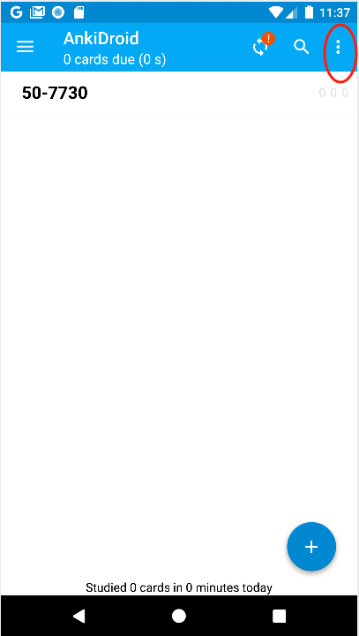

or

Then

